https://www.tkelvin.com/admin/login.php
super-admin
123@admin

cpanel:

https://gator3145.hostgator.com:2083/logout/?locale=en
owlwiz2018
NQsX!Ks-q-q6

TKelvin
Engineering Excellence.Reliable Solutions. Innovating the Future.

- Change “Products” to “Industries”
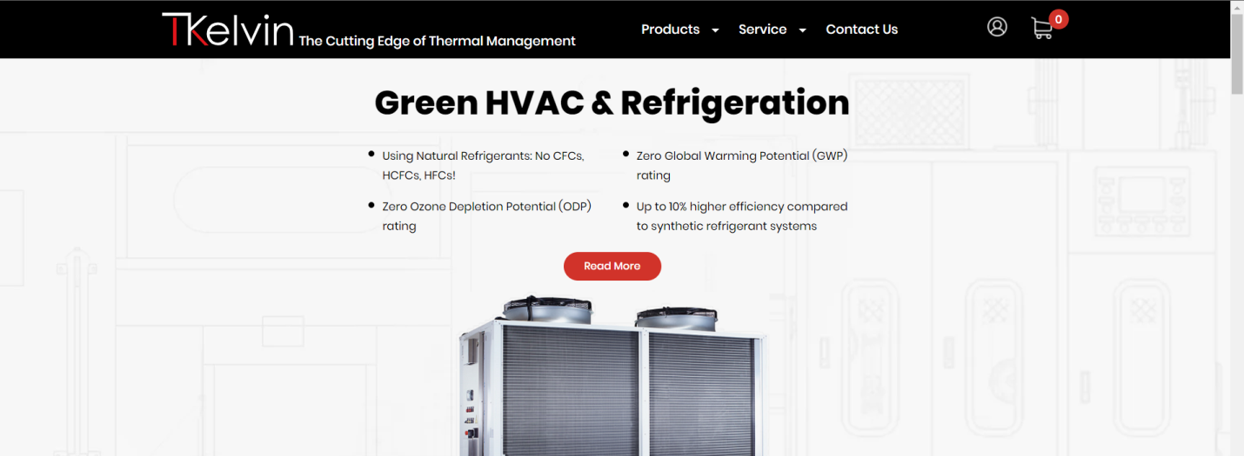
Updated

The following is for me to add, jump to #2
Industries

National Labs and Universities
TKelvin has been successfully supporting and collaborating with National Laboratories and Universities in the design, optimization, and manufacturing of various research projects. Project partners have included Oak Ridge National Laboratory, National Renewable Energy Laboratory, MIT, University of Alabama, and FIU.

Capabilities
- HVAC& refrigeration systems
- Process water system (PCW, LCW, UPW, CHW, HHW)
- Plumbing and process gas
- Thermodynamics &thermal management systems
- Custom heat exchanger
- Advanced material & Alloy
- Additive manufacturing

Defense
TKelvin’s extensive experience in designing mechanical systems for Defense ranges from cooling systems to experimental designs. Project partners have included….

Capabilities
- HVAC & refrigeration systems for harsh environments
- Cooling systems for high heat flux electronics
- Thermal management systems for high-energy lasers
- Custom light-weight components for thermal management systems

Food Processing Plant Systems
TKelvin’s systems solutions and specialty fabrications keep your business running at top efficiency year-round – without costly downtime. We specialize in…Project partners have included…

Capabilities
- Plant design and layout
- Specialty design
- Plant-based extrusion line

Biomedical / Biotechnical
TKelvin is a trusted name in biomedical and biotechnical mechanical systems design. We understand that safety, accuracy, and reliability are paramount.

TKelvin has designed life science and biotech labs to the most exacting specifications. Our projects include sophisticated research and manufacturing facilities that require highly controlled environments and specialized engineering features.
We can also design specialty systems and machines.
you can expect superior results in project quality, budget, and schedule.
TKelvin engineers have extensive experience in the biotech, life science, and biopharma industry.

Capabilities
- Wet and dry labs
- Class 1 to 100,000 clean rooms
- BSL for biohazard and pathogen containment
- Glass wash and sterilization
- Chemical storage and discharge
- Industrial and animal watering systems
- HVAC systems for highly controlled atmospheric conditions
- Air handling units, compressed air, fume hoods, and lab exhaust
- Vacuum discharge and humidification steam systems
- Plumbing and process gas, DI water
- Vivaria

Science & Technology / Biotechnical
TKelvin provides programming, planning, and design services for state-of-the-art instructional and interdisciplinary laboratories (laser, physics, chemistry, biology, and nanotechnology) and related support facilities. They are designed to facilitate reconfiguration to accommodate changes in research and project teams.
Our ability to work with client end-users to create the best space possible is one of the keys to our success. Our mission is to give them an R&D environment conducive to helping them to make breakthroughs in science.

Capabilities
- Laser labs
- Nanotechnology and materials science labs
- Physics labs
- Biology labs
- Vacuum chambers
- Class 1–100,000 clean rooms
- Vivaria
- Cold rooms
- Chemical storage and discharge
- Process piping systems
- Fume hoods / lab exhaust and pressurization

Large Estate Maintenance
TKelvin is the best choice for Bay Area Estate and Historical Estate mechanical maintenance management. Operating a smart, energy-efficient, top-performing property involves analyzing every aspect of the building’s mechanics. From maintaining the HVAC system to water pump systems to wine vault systems, each component plays an important role in the operational efficiency and quality preservation of your home. Investing in mechanical maintenance and preventative services can benefit the functionality and value of your property.
Capabilities
- HVAC: repair, maintenance, efficiency, optimal temps and humidity for valuable artworks
- Water Tanks, Heaters, and Pumps
- Plumbing, Piping, and Lines
- Sprinkler Systems – Fire and Irrigation
- Alarm System
- Elevator Machinery
- Water Pump Systems – Pools, fountains, and man-made lakes
- Wine Vault Systems

- Change “Service” to “Industries”

- Remove these, the website will be informitive only

Updated

- In all “Products” pages that will be changed to “Industries”, change “Quote” to “Contact Us”

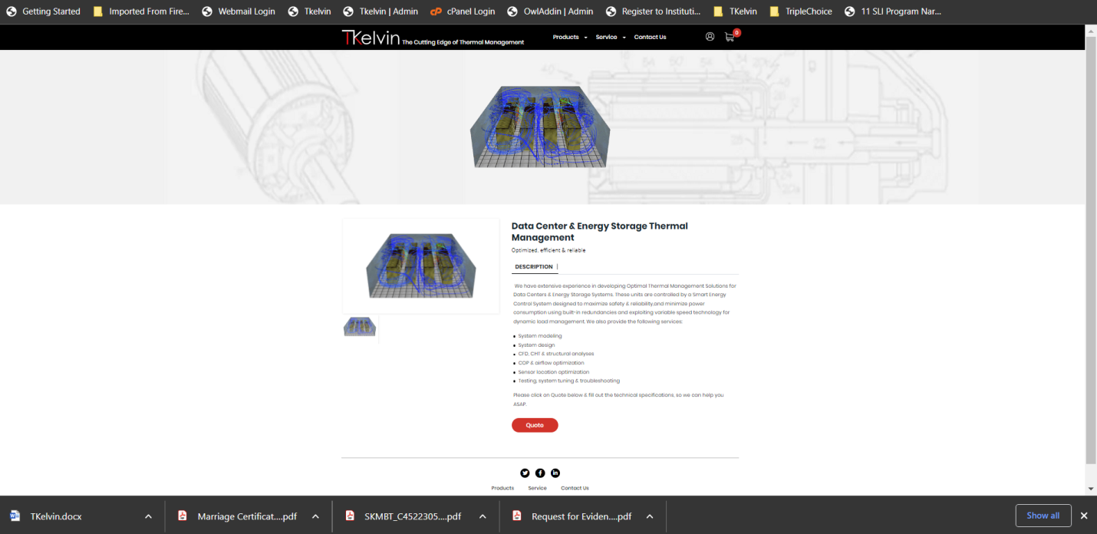

Updated

- I need to change the slogan
Engineering Excellence. Reliable Solutions. Innovating the Future.

Updated

